Div. 2 Helium-Enhanced Semi-Permanent Mold Aluminum Casting – Dr. Paul Sanders (Michigan Technological University); Agreement 12-13#05; 2-E Committee

November 2015 (Yellow)
Accomplishments from last quarter
- MAGMA analysis completed – shows trend of increasing heat conductivity into core with He injection
- Prepared and presented a project summary at “AFS Design and Production of High Quality Aluminum Casting”, Oct 5-7 2015, Nashville, TN
Plans for current quarter:
- Write and submit final report
Programmatic Concerns:

August 2015 (Yellow)
Accomplishments from last quarter
- Draft report in process
- MAGMA analysis – working to correlate simulated metal and core temperatures to measured data
Plans for current quarter:
- Finish MAGMA analysis; show effect of heat extraction from the metal die vs. core with and without He
- Write and submit final report
- Prepare presentation for “AFS Design and Production of High Quality Aluminum Casting”, Oct 5-7 2015, Nashville, TN
Programmatic Concerns:

November 2014 (Green)
Accomplishments from last quarter
- Completed microstructure and mechanical property measurement
- Presented project update to 2E committee on October 7th, 2014
Plans for current quarter:
- MAGMA analysis; Calculate effect of He on HTC based on cooling data
- Complete microstructure and property data analysis
- Write and submit final report – Contract ends November 30th, 2014
Programmatic Concerns:
None

August 2014 (Yellow)
Accomplishments from last quarter
- Sectioned castings for tensile testing and microstructural analysis
- Organized cooling data for MAGMA analysis
- Machining tensile samples and tensile testing in process
Plans for current quarter:
- MAGMA analysis; Calculate effect of He on HTC based on cooling data
- Complete microstructure and property analysis
- Write and submit final report
Programmatic Concerns:
Tensile testing and microstructure analysis is taking longer than expected. Requesting a 3 month extension to finish analysis and reporting.

June 2014 (Green)
Accomplishments from last quarter
- Mold and core box installed and runoff complete at Carley Foundry
- Casting trials complete
- Sectioning castings for microstructure and property analysis in process
Plans for current quarter:
- MAGMA analysis; Calculate effect of He on HTC based on cooling data
- Complete microstructure and property analysis
- Present project update to 2E committee on June 17th, 2014
Programmatic Concerns:
None
February 2014 (Green)
Accomplishments from last quarter
- Helium injection/TC fixture assembly complete
- Mold machining complete
- All mold, core box and He injection/thermocouple assembly parts shipped to Carley Foundry in December
- Preliminary core blown with instrumentation:
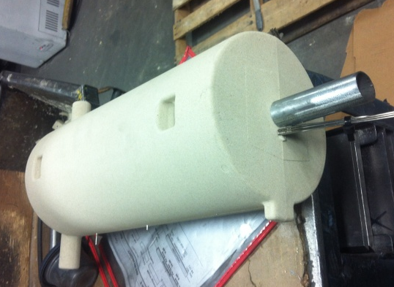
He injection tube
Thermocouples
- Presented project update to 2E committee on January 21st, 2014
Plans for current quarter:
- Core box and mold prep/runoff at Carley
- Casting trials at Carley Foundry (mid-March)
- Microstructure and property analysis

Programmatic Concerns:
The project has fallen slightly behind the original timeline due to mold fabrication taking longer than anticipated. A no cost time extension has been granted to extend the contract through August 2014.

November 2013 (Green)
Accomplishments from last quarter
- Thermocouple placement method refined (added TC support bracket)
- Helium injection/TC fixture assembly in process
- Ordered and received 70 thermocouples from Pyrotek (provided at cost)
- Core box machining complete
- Mold machining nearly complete; estimate 2 weeks to complete
- Presented project update to 2E committee on October 8th, 2013
Plans for current quarter:
- Complete He injection/TC assemblies
- Finish mold machining
- Core box and mold prep/runoff at Carley
- Casting trials at Carley (mid-December)
- Microstructure and property analysis
Programmatic Concerns:
None

August 2013 (Green)
Accomplishments from last quarter
- Project approval and start of contract; March 2013
- Mold and core box CAD complete
- MAGMA simulation of filling and solidification complete
- Refined gating for final design based on simulation results
- Helium injection system designed
- Thermocouple placement method developed
- Received binder core gas evolution model
- Received mold materials from Dura-Bar® (provided in-kind)
- Started core box fabrication
- Presented project update to 2E committee on June 6, 2013
Plans for current quarter:
- Complete mold and core box fabrication
- Complete helium injection system fabrication
- Complete casting trials
Programmatic Concerns:
None

